Corporate Infrastructure Executive Report
College of Science, Engineering, and Technology, Grand Canyon University
ITT-216: Enterprise Route & Switch
Instructor Tim Collins
Liela Pressley
5/14/2023

Corporate Infrastructure Executive Report
New Network Architecture
Our company’s network has received innovative changes to best provide security, efficiency, and accessibility to all of our organization’s users. Starting with the most obvious change, our network has 5 new VLANs catering to each of the 5 new locations of the organization. Each location now has its own wireless network (wi-fi) and a switched network. In order to have an established wireless network, there needs to be a router that connects that location’s network to the main office, a switch to distribute access to relevant PCs, and a wireless access point that provides wireless network capabilities to endpoint devices (laptops, printers, etc.). In addition, there are now 2 remote office routers, which will allow employees who are working remotely to still have full (and secure) access to resources and services required for their jobs.
Next, VLANs also known as virtual local area networks were configured in order to ensure that the different subnets allow relevant network traffic to be accessed. For example, Engineering PC devices will not be able to access a Shipping PC but both PCs will be able to access the DHCP Server if needed. In order to provide many beneficial services for the organization, two servers were added to the network, one DNS server and the other a WWW server. The DNS server not only provides proficiency but also great security improvements such as promoting block requests over ports, stopping malware, and reducing infections to spread on the network.
In addition to physical changes to the network, we implemented security improvements throughout the network. Starting with port security, we were able to limit the number of computers to an access port, creating the least privilege within the network as well as limiting the amount of access a computer has to a high-security port. In case a threat actor is able to detect a vulnerability in one of the services of our network and gains access to it through one of these ports, we reduced the amount of access of the actor. In order to direct and limit traffic to and from different endpoint devices, Access Control Lists were configured. ACLs qualify or unqualify different data packets that are delivered over the network prior to gaining access to their destination. Next Network Address Translation (NAT) was configured, this protocol is important because it prevents the company from using an unnecessary amount of public IP addresses when accessing the public Internet (for both security and financial benefits). When working with large amounts of sensitive and important information, it is necessary to have a backup set up in case a disaster were to occur. This is why FTP and tftp services were implemented. Lastly, a VPN, also known as a virtual private network, was configured in order to provide encrypted data transmission.
To enhance efficiency within the network traffic and routing, we configured various protocols such as OSPF (Open Shortest Path First), EIGRP (Enhanced Interior Gateway Routing Protocol), BGP (Border Gateway Protocol), and RIP (Routing Information Protocol). Each of these protocols works within routers to promote efficient routing allowing our organization to deliver data packets to and from endpoint devices in the quickest and most reliable way possible.
How It All Works
Out of the many improvements, new installations, and implementations provided, there are many important protocols and relationships between devices that allow a great network to run efficiently, be secure, and allow accessibility for its users.
Limiting VLANs- a virtual local area network allows for each location to provide/distribute accessible resources from necessary networking devices to each user’s device. But by configuring multiple VLANs our network is able to provide specific services catered to each department’s needs without overloading, creating unwanted traffic being delivered, and ensuring security. As seen in the illustration below, a virtual LAN segregates traffic to specific groups within the same network without creating a separate subnetwork.
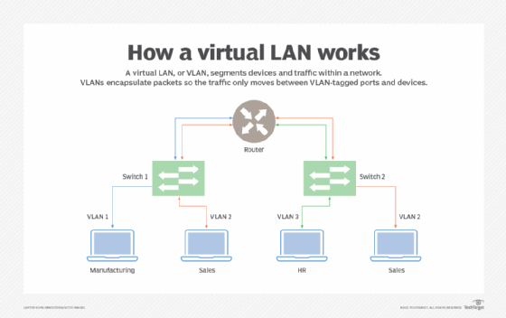
As seen in the diagram of the new network architecture, each department has a VLAN assigned to it by number. Each networking device routes traffic assigned to the devices that are responsible for that VLAN number/department.
Port Security- In short, port security is essential for any network, many threat actors aim to access a network via insecure or open ports. As part of the port security configuration process, we implemented a Mac address sticky and then restricted access to certain access points for certain VLANs that did not require that level of privilege (Figure 2-0).
Figure 2-0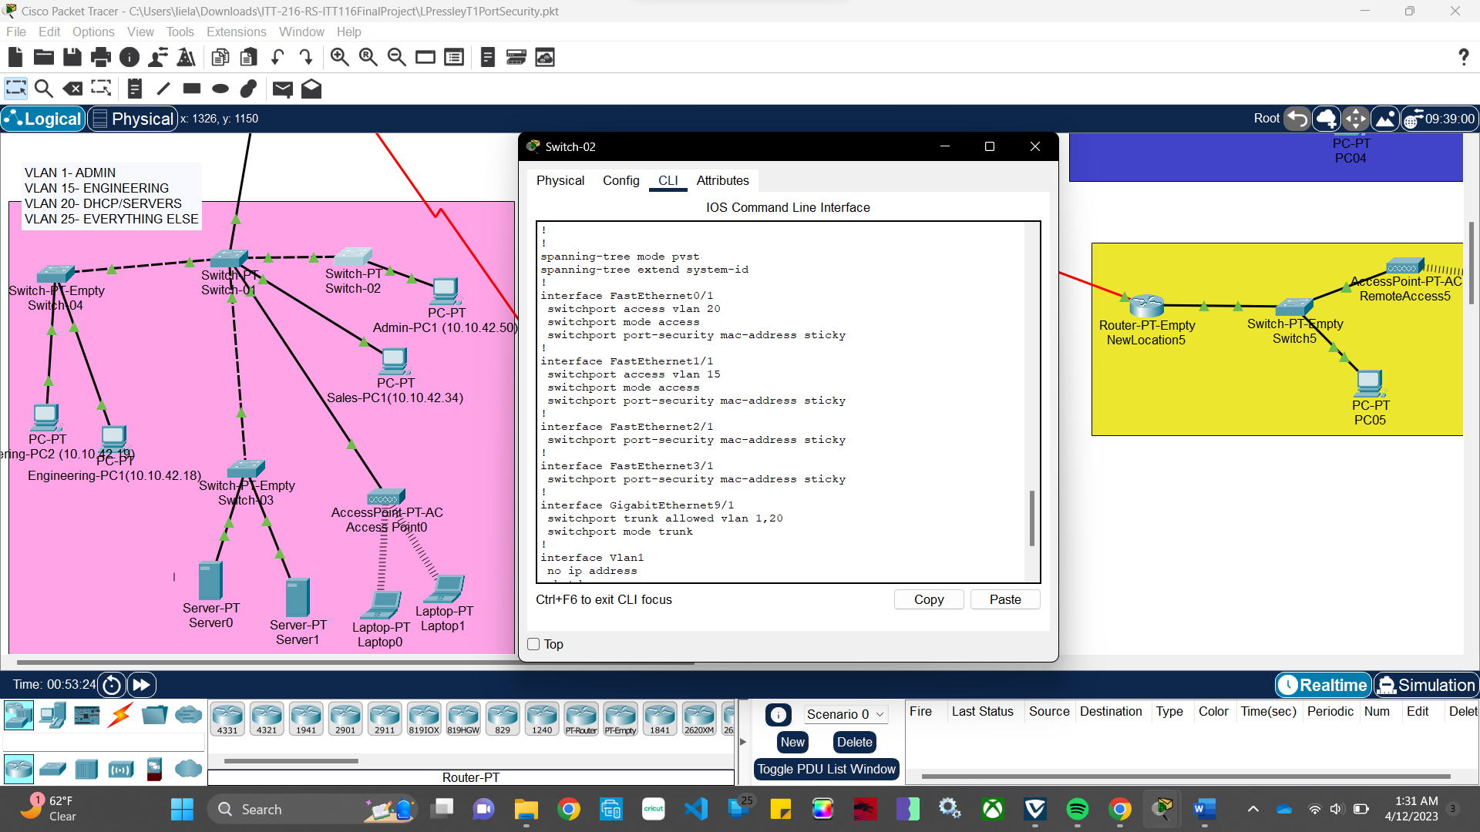

OSPF and RIP Configuration- Overall, OSPF is the way to go when implementing routing protocols, especially for an enterprise network of this size. OSPF stands for Open Shortest Path First and is much newer than Routing Information Protocol (RIP). OSPF collects data about all of the different paths and routes related to it on the network and creates a network topology that it will reference to determine the best path for data. When configuring this, we provided all of the relevant devices on the network that the router will be distributing traffic to so that it can configure the necessary paths. Then we tested for successful connections by pinging another device on the network and ensuring that it received our request to communicate with it.
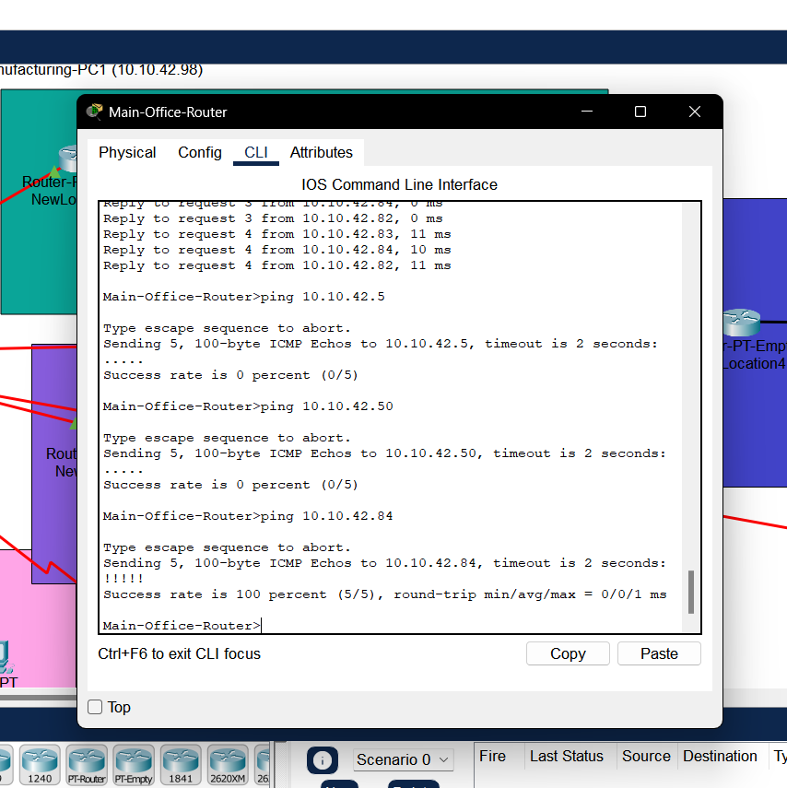

Network Address Translation Protocol- NAT is necessary for the security and financial benefit of our organization. As seen in the illustration below, NAT protocol provides network access to the Internet without having to purchase a multitude of public IP addresses and risking a threat actor seeing a private IP address on one of the devices on the network.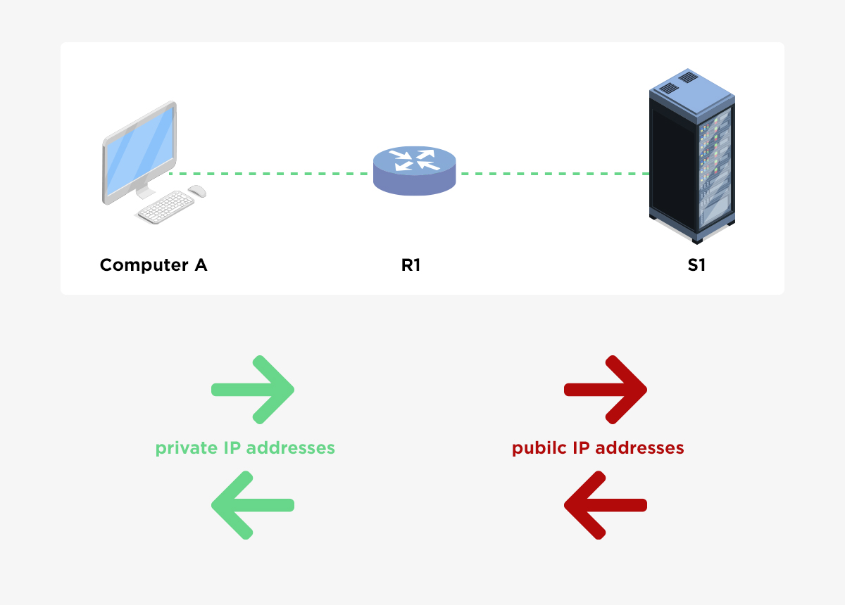
VPN- A virutal private network is a necessary way to ensure that data in transit (information that is traveling across the network), is traveling in a secure manner. Similar to how a tunnel protects cars traveling, a VPN shields network traffic from peeping eyes who may try to see data that is traveling to and from a device and the public Internet. When configuring the VPN on our network, we configured a crypto map on specific ports that we wanted to be encrypted using (MD5 hash, which is essentially an irreversible encryption so that no one can read the information being sent).
